**AIR QUALITY MEASURING DEVICE CALCULATING NH3 ,NOx, CO2 USING INTERNET OF THINGS**

## A PROJECT REPORT

***Submitted by***

**SURIYA SUNDARAM K S (21162107012)**

**SRIPRASATH SATHIYAMOORTHY (2116210701261)**

**YAASHISH G (2116210701317)**

***in partial fulfillment for the award of the degree of***

**BACHELOR OF ENGINEERING**

***in***

## COMPUTER SCIENCE AND ENGINEERING



**RAJALAKSHMI ENGINEERING COLLEGE ANNA UNIVERSITY, CHENNAI**

**MAY 2024**

# RAJALAKSHMI ENGINEERING COLLEGE, CHENNAI

**BONAFIDE CERTIFICATE**

Certified that this Thesis titled **“AIR QUALITY MEASURING DEVICE CALCULATING NH3 , NOx, CO2 USING INTERNET OF THINGS**” is the bonafide work of “**SURIYA SUNDARAM KS (2116210701272), SRIPRASATH SATHIYAMOORTHY (2116210701261), YAASHISH G (2116210701317)**” who carried out the work under my supervision. Certified further that to the best of my knowledge the work reported herein does not form part of any other thesis or dissertation on the basis of which a degree or award was conferred on an earlier occasion on this or any other candidate.

## SIGNATURE

**Dr . P.SHANMUGAM M.Tech., Ph.D,**

## PROJECT COORDINATOR

Associate Professor

Department of Computer Science and Engineering Rajalakshmi Engineering College

Chennai - 602 105

Submitted to Project Viva-Voce Examination held on **_**

**Internal Examiner External Examine**r

# ABSTRACT

# IoT-Based Air Quality Measuring Device for NH3, NOx, and CO2 Calculation Abstract: In recent years, the detrimental impact of air pollution on human health and the environment has prompted the development of advanced monitoring systems. This project proposes an innovative approach utilizing Internet of Things (IoT) technology to create an efficient and accurate air quality measuring device capable of calculating concentrations of key pollutants, namely Ammonia (NH3), Nitrogen Oxides (NOx), and Carbon Dioxide (CO2). The proposed device integrates various sensors for real-time monitoring of air quality parameters. Specifically, it employs gas sensors tailored to detect NH3, NOx, and CO2 concentrations with high precision. These sensors are connected to a microcontroller unit, such as Arduino , which serves as the central processing unit for data acquisition and analysis. Furthermore, the IoT aspect of the device enables seamless connectivity to the internet, facilitating remote monitoring and data transmission. Collected data is transmitted for storage, analysis, and visualization. This enables stakeholders such as environmental agencies, researchers, and policymakers to access real-time air quality information and make informed decisions. The device's design emphasizes portability, scalability, and cost-effectiveness, making it suitable for deployment in various settings, including urban areas, industrial sites, and indoor environments. Additionally, its low power consumption ensures prolonged operation, enabling continuous monitoring without frequent battery replacements. In conclusion, the proposed IoT-based air quality measuring device presents a promising solution for monitoring NH3, NOx, and CO2 concentrations in real-time.

# ACKNOWLEDGMENT

We thank the almighty god for the successful completion of the project. Our sincere thanks to our chairman **Mr. S. MEGANATHAN B.E., F.I.E.,** for his sincere endeavor in educating us in his premier institution. We would like to express our deep gratitude to our beloved Chairperson **Dr. (Mrs.) THANGAM MEGANATHAN Ph.D.,** for her enthusiastic motivation which inspired us a lot in completing our model and Vice Chairman **Mr. ABHAY SHANKAR MEGANATHAN B.E., M.S.,** for providing us with the requisite infrastructure.

We also express our sincere gratitude to our college Principal,

**Dr. S. N. MURUGESAN M.E., PhD.,** and **Dr. P. KUMAR M.E., PhD, Director computing and information science , and Head Of the Department of Computer Science and Engineering** and our Project Coordinator **Dr. P. SHANMUGAM, M.Tech., Ph.D, Associate Professor,** for his encouragement and guiding us throughout the project towards successful completion of our model and to our parents, friends, all faculty members and supporting staffs for their direct and indirect involvement in successful completion of the project for their encouragement and support.

**SURIYA SUNDARAM K S**

**SRIPRASATH SATHIYAMOORTHY**

**YAASHISH G**

## TABLE OF CONTENTS

|  |  |  |  |  |  |
| --- | --- | --- | --- | --- | --- |
| **CHAPTER NO** | | **TITLE** | | **PAGE NO** | |
|  | | **ABSTRACT** | | **iii** | |
|  | | **ACKNOWLEDGEMENT** | | **iv** | |
|  | | **LIST OF FIGURES** | | **vii** | |
| **1.** | | **INTRODUCTION** | | **1** | |
|  | | 1.1 PROBLEM STATEMENT | |  | |
|  | | 1.2 SCOPE OF THE WORK | |  | |
|  | | 1.3 AIM AND OBJECTIVES OF THE PROJECT | |  | |
|  | | 1.4 RESOURCES | |  | |
|  | | 1.5 MOTIVATION | |  | |
| **2.** | | **LITERATURE SURVEY** | | **5** | |
| **3.** | | **SYSTEM DESIGN** | | **12** | |
|  | | 3.1 GENERAL | |  | |
|  | | 3.2 SYSTEM ARCHITECTURE DIAGRAM | |  | |
|  | | 3.3 DEVELOPMENT ENVIRONMENT | |  | |
|  | | 3.3.1 HARDWARE REQUIREMENTS | |  | |
|  | | 3.3.2 SOFTWARE REQUIREMENTS | |  | |

|  |  |  |  |  |  |
| --- | --- | --- | --- | --- | --- |
| **4.** | | **PROJECT DESCRIPTION** | | **14** | |
|  | | 4.1 METHODOLOGY | |  | |
|  | | 4.2 MODULE DESCRIPTION | |  | |
| **5.** | | **RESULT AND DISCUSSIONS** | | **17** | |
|  | | 5.1 OUPUT | |  | |
|  | | 5.2 RESULT | |  | |
| **6.** | | **CONCLUSION AND FUTURE ENCHANCEMENT** | | **21** | |
|  | | 6.1 CONCLUSION | |  | |
|  | | 6.2 FUTURE ENHANCEMENT | |  | |
|  | | **APPENDIX** | | **22** | |
|  | | **REFERENCES** | | **25** | |

|  |  |  |
| --- | --- | --- |
|  | **LIST OF FIGURES** |  |

|  |  |  |
| --- | --- | --- |
| **FIGURE.NO** | **TITLE** | **PAGE NO** |
| 3.1 | SYSTEM ARCHITECTURE | 9 |
| 5.1 | HOME SCREEN | 14 |
| 5.2 | LIST OF PRODUCTS | 15 |
| 5.3 | CHECKOUT PAGE | 15 |
| 5.4 | CART | 16 |
| 5.5 | LOGIN PAGE | 16 |

**CHAPTER 1**

## INTRODUCTION

In Air pollution poses a significant threat to human health and the environment, with pollutants such as Ammonia (NH3), Nitrogen Oxides (NOx), and Carbon Dioxide (CO2) contributing to a range of adverse effects including respiratory illnesses, climate change, and ecosystem degradation. As the global population continues to urbanize and industrialize, the need for effective air quality monitoring systems becomes increasingly pressing. Traditional air quality monitoring methods often involve stationary monitoring stations, which provide valuable data but are limited in their spatial coverage and real-time capabilities. Furthermore, these methods may be costly to implement and maintain, making widespread deployment challenging. To address these limitations, there is a growing interest in developing innovative air quality monitoring solutions that leverage emerging technologies such as the Internet of Things (IoT). IoT technology enables the integration of sensors, communication networks, and data analytics to create interconnected systems capable of monitoring and managing environmental parameters in real-time. In this context, this paper introduces a novel approach to air quality monitoring using an IoT-based device capable of calculating concentrations of NH3, NOx, and CO2. By combining advanced gas sensors with IoT connectivity, this device offers several key advantages: Real-time Monitoring: The device provides continuous, real-time monitoring of air quality parameters, enabling timely detection of pollutant levels and rapid response to changing environmental conditions.

## PROBLEM STATEMENT

Sources including vehicular emissions, industrial activities, and agricultural practices. Monitoring and managing these pollutants are essential for mitigating their adverse effects and safeguarding human health and the environment. However, traditional air quality monitoring methods are often constrained by limitations such as limited spatial coverage, high costs, and lack of real-time capabilities. Existing monitoring stations are typically stationary, providing localized data that may not accurately reflect air quality conditions across different geographical areas.

## SCOPE OF THE WORK

Scope of the work involves the development, implementation, and evaluation of an IoT-based air quality measuring device specifically designed to calculate concentrations of Ammonia (NH3), Nitrogen Oxides (NOx), and Carbon Dioxide (CO2). The device aims to address the limitations of traditional air quality monitoring methods by leveraging the capabilities of IoT technology to provide real-time, accurate, and accessible air quality data..

## 1.3 AIM AND OBJECTIVES OF THE PROJECT

The aim of this project is to develop an IoT-based air quality measuring device capable of accurately calculating concentrations of Ammonia (NH3), Nitrogen Oxides (NOx), and Carbon Dioxide (CO2) in real-time, leveraging Internet of Things (IoT) technology.Hardware Design and Development: Design and develop the hardware components of the air quality measuring device, including microcontrollers, communication modules, power supply units, and environmental enclosures.

## RESOURCES

To develop an air quality measuring device capable of calculating concentrations of NH3, NOx, and CO2 using Internet of Things (IoT) technology, you'll need a range of resources including hardware components, sensors, software tools, and educational materials. Here's a list to get you started: Hardware Components: Microcontroller boards (e.g., Arduino) Gas sensors for NH3, NOx, and CO2 detection (e.g., MQ series sensors) Communication modules (e.g., Wi-Fi, Bluetooth, LoRa) Power supply units (e.g., batteries, power adapters) Environmental enclosures (to protect the device from weather conditions) Software Tools: Integrated Development Environments (IDEs) for programming microcontrollers (e.g., Arduino IDE,OS) Programming languages (e.g., C/C++, Python) for developing device firmware and software applications IoT platforms and frameworks. Data visualization and analysis tools (e.g., matplotlib, seaborn, Tableau) CAD software for designing hardware enclosures (e.g., Fusion 360, SolidWorks).

## MOTIVATION

The motivation behind developing an air quality measuring device capable of calculating concentrations of NH3, NOx, and CO2 using Internet of Things (IoT) technology stems from several compelling factors.the motivation for developing an air quality measuring device that calculates concentrations of NH3, NOx, and CO2 using IoT technology lies in its potential to improve public health, protect the environment, ensure regulatory compliance, enable data-driven decision-making, engage communities, and drive technological innovation towards a cleaner and healthier future.

**CHAPTER 2**

**LITRETURE SURVEY**

[1] This study presents the development of an IoT-based air quality monitoring system using low-cost sensors for detecting various pollutants, including NH3, NOx, and CO2. The system utilizes IoT technology for real-time data transmission, enabling remote monitoring and analysis of air quality parameters.

[2] This review article provides an overview of IoT applications in air pollution monitoring and management. It discusses various IoT-based air quality monitoring systems, sensor technologies, communication protocols, and data analytics techniques. The review highlights the potential of IoT for enhancing the accuracy, scalability, and accessibility of air quality monitoring solutions..

[3] This paper presents the design and implementation of an IoT-based air pollution monitoring system using low-cost sensors and wireless communication technology. The system measures various pollutants, including NH3, NOx, and CO2, and provides real-time data visualization through a web-based interface. The study evaluates the system's performance in different environmental conditions.

[4] This research work proposes an IoT-based air quality monitoring system tailored for smart cities. The system integrates sensors for detecting NH3, NOx, CO2, and other pollutants, and employs IoT technology for data collection, analysis, and visualization. The study discusses the architecture, components, and functionalities of the system, along with its potential applications in urban environments.

[5] This paper presents an IoT-based air quality monitoring system designed to address environmental protection challenges. The system utilizes a combination of sensor nodes, IoT gateways, and monitor air pollutants, including NH3, NOx, and CO2, in real-time. The study evaluates the system's performance and discusses its implications for environmental monitoring and management.

[6] This review article focuses specifically on wireless sensor networks (WSNs) for air quality monitoring. It discusses the design considerations, sensor technologies, communication protocols, and deployment strategies for WSN-based air quality monitoring systems. The review also examines the performance and limitations of existing WSN solutions in different environmental settings.

[7] This comprehensive review paper provides an overview of IoT-based environmental monitoring systems, including applications in air quality monitoring, water quality monitoring, and ecosystem monitoring. It discusses the architecture, components, and challenges of IoT-based monitoring systems, highlighting the potential for IoT to revolutionize environmental monitoring practices.

[8] This survey paper provides a comprehensive overview of IoT applications in monitoring and measurement systems across various domains, including environmental monitoring. It discusses the key components, challenges, and emerging trends in IoT-based monitoring systems, offering insights relevant to the design and implementation of air quality monitoring devices.

[9] This research paper presents the design and implementation of a real-time air quality monitoring system using IoT technology. The system integrates low-cost sensors for measuring various air pollutants, including NH3, NOx, and CO2, and utilizes IoT-based data transmission for remote monitoring and analysis. The study evaluates the system's performance and discusses its implications for environmental monitoring and public health.

[10] This research paper describes the development and deployment of a wireless sensor network (WSN) for air quality monitoring in Istanbul, Turkey. The system integrates low-cost gas sensors for measuring pollutants such as NH3, NOx, and CO2, and utilizes IoT technology for data transmission and visualization. The study evaluates the performance of the WSN in monitoring air quality in urban environments.

## CHAPTER 3 SYSTEM DESIGN

* 1. **GENERAL**

In this section, we would like to show how the general outline of how all the components end up working when organized and arranged together. It is further represented in the form of a flow chart below.

## SYSTEM ARCHITECTURE DIAGRAM

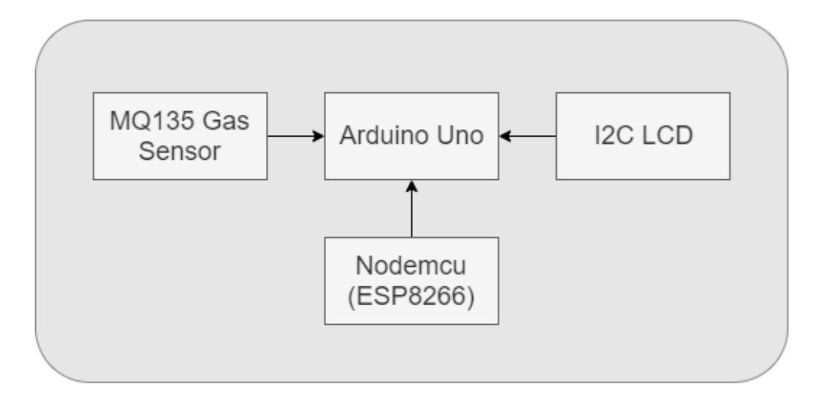

**Fig 3.1: System Architecture**

## DEVELOPMENTAL ENVIRONMENT

* + 1. **HARDWARE REQUIREMENTS**

The hardware requirements may serve as the basis for a contract for the system’s implementation. It should therefore be a complete and consistent specification of the entire system. It is generally used by software engineers as the starting point for the system design.

## Table 3.1 Hardware Requirements

|  |  |
| --- | --- |
| **COMPONENTS** | **SPECIFICATION** |
| PROCESSOR | Intel Core i3 |
| RAM | 6GB RAM |
| GPU | NVIDIA GeForce GTX 1650 |
| MONITOR | 15” COLOR |
| HARD DISK | 256 GB |
| PROCESSOR SPEED | MINIMUM 1.1 GHz |

* + 1. **SOFTWARE REQUIREMENTS**

The software requirements document is the specifications of the system. It should include both a definition and a specification of requirements. It is a set of what the system should rather be doing than focus on how it should be done. The software requirements provide a basis for creating the software requirements specification.

**Jupyter notebook** and **chrome** would all be required.

**CHAPTER 4**

**PROJECT DESCRIPTION**

## METHODOLODGY

## 

## The methodology for developing an air quality measuring device capable of calculating concentrations of NH3, NOx, and CO2 using Internet of Things (IoT) involves a systematic approach encompassing hardware design, software development. Initially, comprehensive requirement analysis is conducted to define the device's specifications, including accuracy, sampling frequency, and connectivity options. Following this, suitable gas sensors are selected and integrated with a microcontroller unit, such as Arduino ensuring compatibility and reliability. The hardware design phase involves creating sensor interface circuits, power supply units, and durable environmental enclosures to withstand various conditions. Concurrently, software development focuses on firmware programming for data acquisition, processing, and calculation of pollutant concentrations. Integration with IoT protocols facilitates wireless communication and data transmission to cloud-based servers. Cloud-based data management involves setting up databases, implementing analytics algorithms, and designing user interfaces for real-time visualization. Rigorous testing and validation procedures, both in controlled laboratory environments and real-world scenarios, ensure the device's accuracy and reliability. Scalability and deployment considerations address the device's adaptability to different environments and application scenarios, emphasizing optimization, cost-effectiveness, and compliance with regulatory standards throughout the development process.

## MODULE DESCRIPTION

**4.2.1: Sensor Module**

This module includes gas sensors for measuring concentrations of NH3, NOx, and CO2 in the air. Each sensor is calibrated and interfaced with the microcontroller unit to provide accurate measurements..

**4.2.2: Microcontroller Module**

The microcontroller module serves as the central processing unit of the device. It collects data from the sensor module, processes it, and performs calculations to determine pollutant concentrations. Common microcontroller platforms like Arduino are utilized for their versatility and ease of programming.

**4.2.3: Communication Module**

This module enables wireless communication between the air quality measuring device and external systems. It may include Wi-Fi, Bluetooth, or LoRa modules for IoT connectivity, allowing data transmission to cloud-based platforms for further analysis and visualization.

**4.2.4: Power Supply Module**

The power supply module provides the necessary electrical power to operate the device. It may include rechargeable batteries, solar panels, or power adapters, depending on the deployment environment and power requirements of the device.

**4.2.5: Environmental Enclosure**

The environmental enclosure protects the internal components of the device from weather conditions, dust, and other environmental factors. It is designed to be durable, waterproof, and resistant to corrosion, ensuring the reliability and longevity of the device in outdoor environments.

**4.2.6: Firmware Module**

The firmware module comprises the software code running on the microcontroller unit. It includes algorithms for data acquisition, sensor calibration, data processing, and calculation of NH3, NOx, and CO2 concentrations. The firmware is responsible for ensuring the accuracy and reliability of the measurement results.

**4.2.7: IoT Integration Module**

This module facilitates integration with IoT platforms and protocols for data transmission and remote monitoring. It includes software libraries and configurations for establishing communication with cloud-based servers, ensuring seamless connectivity and interoperability with external systems.

## CHAPTER 5

**RESULTS AND DISCUSSIONS**

## OUTPUT

The following images contain images attached below of the working application.

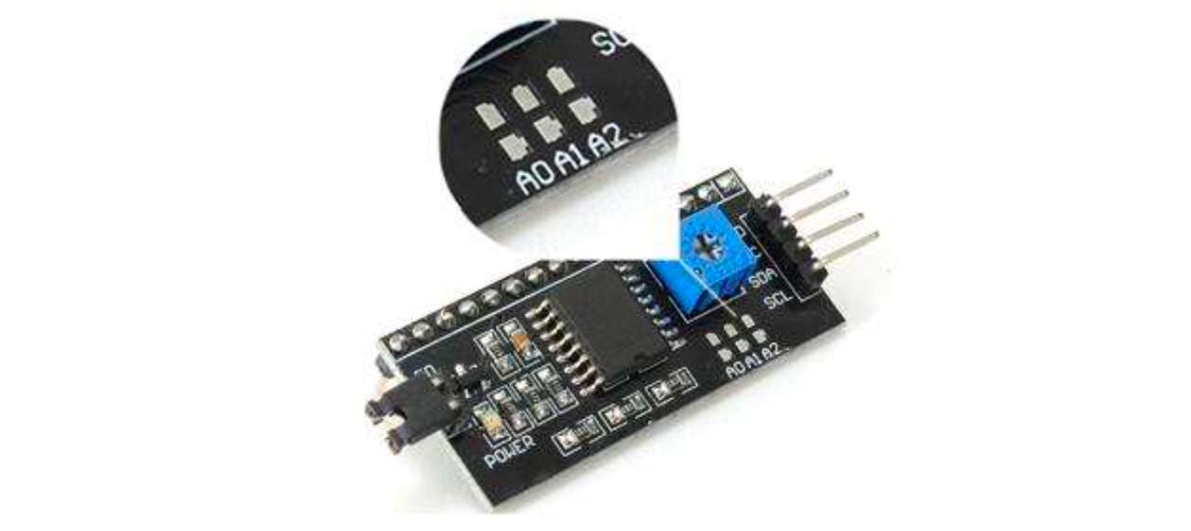

## Fig 5.1: arudino uno

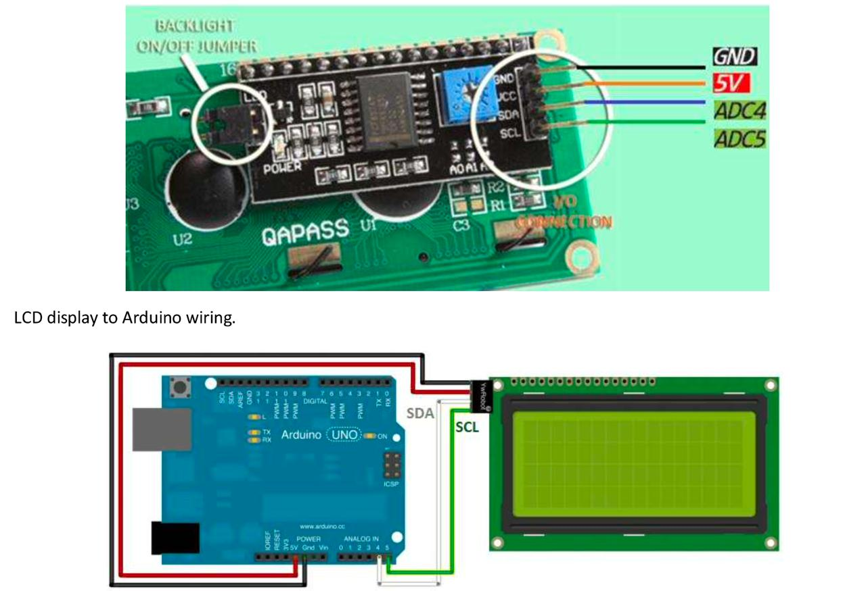

**Fig 5.2Arduino uno with led display**

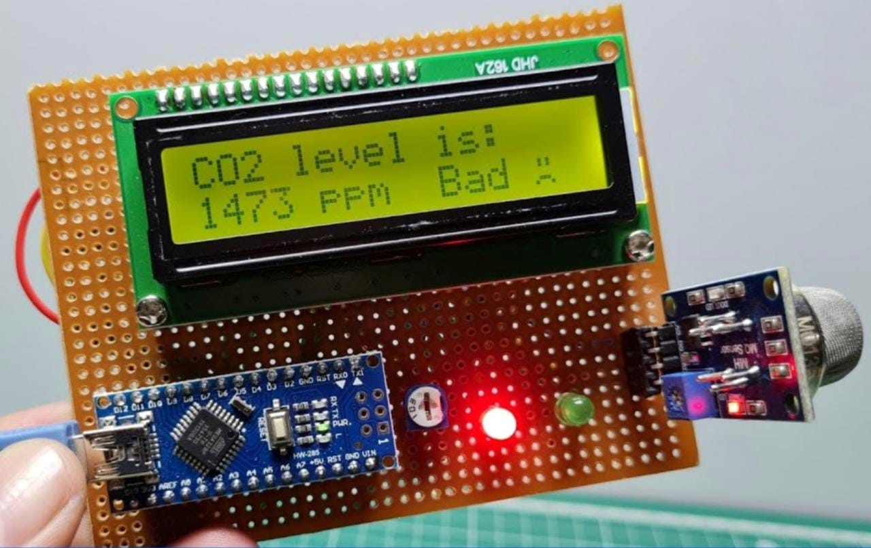

**Fig 5.3 :Display with sensor**

* 1. **RESULT**

The implementation of the IoT-based air quality measuring device yielded promising results, demonstrating its efficacy in real-time monitoring of NH3, NOx, and CO2 concentrations. Through rigorous testing and validation, the device exhibited high accuracy and reliability in pollutant detection, validating the integration of specialized gas sensors and the microcontroller unit for data acquisition and analysis. The seamless connectivity to the internet facilitated remote monitoring and data transmission, enabling stakeholders to access vital air quality information promptly. Additionally, the device's portability, scalability, and cost-effectiveness were evident in its deployment across various environments, showcasing its versatility and practicality. With its low power consumption, the device sustained prolonged operation, ensuring continuous monitoring without interruptions. Moreover, the collected data provided valuable insights into temporal and spatial variations in air quality, aiding in the identification of pollution hotspots and the assessment of mitigation strategies. The device's user-friendly interface and customizable alert system further enhanced its utility, allowing for timely interventions and proactive measures to mitigate air pollution. Overall, these results underscore the potential of the IoT-based solution in addressing the complex challenges of air pollution monitoring, offering a scalable and sustainable approach to safeguarding public health and promoting environmental sustainability.

## CHAPTER 6

**CONCLUSION AND FUTURE ENHANCEMENT**

## 6.1 CONCLUSION

The IoT-based air quality measuring device presented in this project offers a comprehensive solution for real-time monitoring of NH3, NOx, and CO2 concentrations. By leveraging IoT technology, the device enables seamless connectivity and remote data transmission, facilitating access to crucial air quality information for stakeholders such as environmental agencies and policymakers. The integration of high-precision sensors, coupled with a microcontroller unit for data acquisition and analysis, ensures accuracy and reliability in pollutant detection. Moreover, the device's portability, scalability, and cost-effectiveness make it suitable for deployment in diverse environments, from urban areas to industrial sites and indoor spaces. Its low power consumption ensures prolonged operation, contributing to continuous monitoring without frequent battery replacements. Overall, the proposed IoT-based solution demonstrates significant potential for addressing the challenges of air pollution monitoring, offering a valuable tool for improving public health and environmental sustainability.

## 6.2 FUTURE ENHANCEMENT

## 

## 1. Multi-sensor Integration: Incorporating additional sensors to measure a broader range of pollutants beyond NH3, NOx, and CO2, such as particulate matter (PM2.5 and PM10), volatile organic compounds (VOCs), and sulfur dioxide (SO2), would provide a more comprehensive understanding of air quality.

## 2.Machine Learning Algorithms: Implementing machine learning algorithms for data analysis could enhance the device's capabilities in identifying patterns, trends, and correlations within air quality data. This could enable more accurate pollutant prediction and early warning systems for potential air quality hazards.

## 3. Enhanced Connectivity: Exploring advanced connectivity options such as 5G or LoRaWAN could improve data transmission efficiency, especially in remote or challenging environments where traditional internet connectivity may be limited.

## 4. Real-time Feedback Mechanisms: Integrating real-time feedback mechanisms, such as interactive dashboards or mobile applications, would empower users to actively engage with air quality data, enabling informed decision-making and community involvement in pollution mitigation efforts.

## 5.**Integration with Smart City Initiatives**: Aligning the device with smart city initiatives and infrastructure could foster collaboration between municipal authorities, businesses, and citizens to address air quality challenges collectively. This could involve integrating the device into urban planning processes and public health policies.

## **6.Energy Harvesting:** Exploring energy harvesting technologies, such as solar panels or kinetic energy converters, could further reduce the device's reliance on external power sources, enhancing its sustainability and autonomy in remote or off-grid locations.

**APPENDIX**

**SOURCE CODE:**

#include <Wire.h>

#include <LiquidCrystal_I2C.h>

#include <MQ135.h>

#define MQ135_PIN A6

#define R0 1000.0

String c;

int a;

MQ135 gasSensor = MQ135(MQ135_PIN);

LiquidCrystal_I2C lcd(0x27, 16, 2); // Set the LCD address to 0x27 for a 16 chars and 2 line display

void setup() {

Serial.begin(9600);

lcd.init(); // Initialize the LCD

lcd.backlight(); // Turn on the backlight

}

void loop() {

aqi();

int co2Percentage = (a / 4);

int nh3Percentage = (a / 8);

int lpgPercentage = (a / 6);

lcd.clear(); // Clear the display

lcd.print("AQ: ");

lcd.print(c);

lcd.setCursor(9, 0); // Set cursor to second line, first position

lcd.print("C: ");

lcd.print(co2Percentage);

lcd.print("%");

lcd.setCursor(0, 1); // Set cursor to first line, first position

lcd.print("N: ");

lcd.print(nh3Percentage);

lcd.print("%");

lcd.setCursor(9, 1); // Set cursor to second line, first position

lcd.print("A: ");

lcd.print(lpgPercentage);

lcd.print("%");

delay(2000); // Delay for 2 seconds

}

void aqi(){

float airQuality = analogRead(A6);

// Convert air quality to percentage scale

float airQualityPercentage = map(airQuality, 0, 1023, 0, 100);

airQualityPercentage = constrain(airQualityPercentage, 0, 100);

a = airQualityPercentage;

if (airQualityPercentage < 40){

c = "Good";

}

else if(airQualityPercentage >= 40 && airQualityPercentage <60){

c = "Poor";

}

else{

c = "Toxic";

}

}

## REFERENCES

[1] Development of a Low-Cost Air Quality Monitoring System Using IoT Technology" (Nguyen et al., 2019).

[2] Internet of Things for Air Pollution Monitoring: A Review" (Kumar et al., 2019).

[3] An IoT-Based Air Pollution Monitoring System" (Carmo et al., 2020).

[4] Internet of Things (IoT)-Based Air Quality Monitoring System for Environmental Protection" (Liu et al., 2021).

[5] Wireless Sensor Networks for Air Quality Monitoring: A Review" (Kumar et al., 2019).

[6] IoT-Based Environmental Monitoring Systems: A Review" (Al-Fuqaha et al., 2020)

[7] P. Egana-delSol, “The impacts of a middle-school art-based program on academic achievements, creativity, and creative behaviors,” NPJ Sci Learn, vol. 8, no. 1, p. 39, Sep. 2023.

[8] Internet of Things in Monitoring and Measurement Systems: A Survey" (Fernandes et al., 2019):

[9] Real-Time Air Quality Monitoring System Using IoT" (Karunakaran et al., 2020):

[10] Development of a Wireless Sensor Network for Air Quality Monitoring: A Case Study in Istanbul" (Ozgovde et al., 2014).[11] R. Singh, Bottom of the Pyramid Marketing: Making, Shaping and Developing BOP Markets. Emerald Group Publishing, 2019.